# From Rome to Home: The West Coast

Places mentioned in this post:

Rome, Italy

Ostia, Italy

Cerveteri, Italy

Ladispoli, Italy

Civitavecchia, Italy

Siena, Italy

Day Three (of five):

We had a good night of sleep at the temple patron housing next to the Rome Italy Temple. I was a little concerned about my coughing fits that were still all too common, and how this might be disruptive during our upcoming temple session. I figured that I could do my very best to prevent one by: eating breakfast as early as possible (so I could work through any coughing afterwards), drinking some hot herbal tea, bringing several cough drops to put into my pocket for the temple session, and PRAYERS. Lots and lots of prayers.

We stripped our bed and tidied up the room as directed, part of the responsibilities of being a guest at the temple patron housing, which was free. While I finished getting ready, Scott took our linens to the laundry room and emptied our trash down the hall.

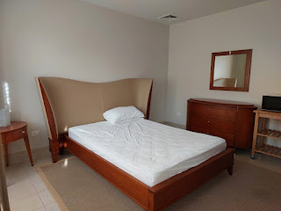

Check-out here is at 9:00 a.m. so we made sure we complied with that as well. The room looked really nice when we left . . .

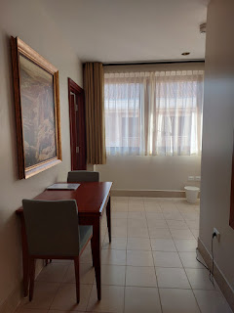

We spent a few minutes walking around the temple grounds, enjoying the morning sunshine and the beautiful flowers while we waited to go inside for our endowment session.

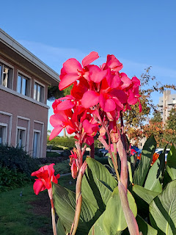

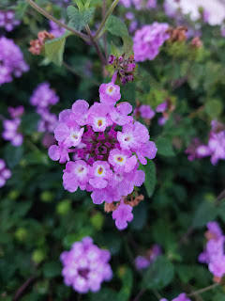

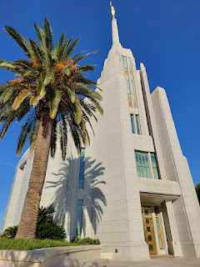

I had a really special experience in the temple that I would like to share. As I mentioned earlier, I wanted to do everything I could possibly do to prevent an obnoxious coughing fit in the temple.  The temple is such a quiet place, so reverent . . . and I didn't want to be THAT person, coughing and coughing loudly while everyone around me wonders when will it stop, did she bring ANY cough drops, and does she have Covid?? I prayed several times, even though technically, God will answer your prayer in His own way, even if it's just one prayer.

I was doing so well . . . and then about 3/4 through the session, I got that tickle in my throat and things quickly went from bad to worse. My cough drops weren't doing anything to help . . . and it felt like my whole body was convulsing as I tried to suppress the coughs. I could not get things under control, and I was so embarrassed. I just kept praying the same words over and over in my mind, "Heavenly Father, please help me to stop coughing so I don't disrupt the sweet spirit of this session . . . "

Eventually, I was able to get it under control and the coughing fit finally ended. My eyes were watering and I dreaded having to speak out loud during the interactive portion just before we enter the Celestial Room, a room that symbolically represents the part of Heaven where God and Jesus Christ reside. I worried that the moment I had to open my mouth, more coughs would come out.

Somehow I made it into the Celestial Room without any embarrassing disasters, thank goodness. I found a place to sit where I could wait for Scott to come in and join me. As I sat there, my eyes immediately filled with tears because I felt filled to the brim with the love that my Father in Heaven has for me.

The spirit whispered to me to look around at various features in the Celestial Room:

The thousands of individual crystals in the huge chandelier hanging above me in the center of the room.

The dozens of carefully crafted leaf patterns in the stained glass windows.

The gold trimwork on the round wooden table in the center of the room.

The etching details around the door panels.

The floral embossing patterns in the cream-colored carpets beneath my feet.

The laborious gold-leaf stencil work on the ceiling high above.

And then the words came into my mind, "Just as I am in the details of the beauty of this room, I am in the details of your life." I felt a rush of love and reassurance that, even though I did have that embarrassing coughing fit, He was still there with me. He is not always going to take away our suffering just to make things easier for us, but that doesn't mean He doesn't love us or care about what we're going through. He wanted me to know that even when things get difficult, or uncomfortable, or sideways, He is still right there.

It was such a powerful realization, even though deep down I already knew this. I just needed to be reminded of it. I could hardly wait for Scott to come into the Celestial Room so I could share in whispers what I had just experienced.

As we left the temple a short time later, we held hands on the way to the car. We walked more slowly, because that's how it feels after you leave the House of the Lord. There is less of a sense of rush, rush, rush, and instead - there's more of a feeling of peace, reassurance, warmth, and fulfillment. We commented to each other that we were both feeling this strong and powerful sense of peace and reassurance. I even said to Scott, "If an asteroid landed right in front of us right now, and everything was obliterated, everything will be okay." And we both agreed, it will all be okay. No matter what happens. That's the peace that the gospel brings, and that's what it means to lean on the Savior, to trust in Him and in His words. This is the feeling that I speak of whenever I attend the temple. It is such a wonderful gift that we receive in the House of the Lord, one that would be difficult, if not impossible, to recreate anywhere else.

We changed our clothes and ate the last of our snacks that we had tucked into the huge fridge that is part of the patron housing kitchen. Sadly, it was time to leave the temple and head out into the big, big world again.

Ostia:

(Pronounced like Austria, but without the "r". OSS-chee-a) This is somewhat of a hidden gem on the west coast, just 25 minutes from the Temple. Two years ago, our friends Rich and Andrea Garner really wanted to visit this place, but we just couldn't squeeze out enough time in our very cramped schedule. I had never heard of it before, until Rich told us about it, but we put it back on our radar as we looked for places to visit on our road trip.

Here is a fantastic article about Ostia from the Rick Steves website:

https://www.ricksteves.com/watch-read-listen/read/articles/ostia-antica-near-rom

e

Ostia Antica is the name of the archaeological site of the ancient Roman port, while Ostia is the name of the modern city situated near the ruins. Ostia was founded around 620 BC and used to be the main port for Rome. It was abandoned in the 9th century AD when it was sacked by Arab pirates during the Battle of Ostia. The site was largely forgotten until excavations were carried out under the orders of Mussolini from 1939-1942.

It was very easy to get here and park in the spacious parking lot. There is a long paved lane that leads up to the ticket office, lined with trees and grassy areas on each side. Ticket prices to get in were reasonable, at 18 euros each. Students get in for free (if you're from Europe), plus every first Sunday of the month,

everyone

can get in for free.

There are frequent maps along the main "street" (seen in the photo below) so you can gauge where you are. There is so much to see here, and the recommended 1.5-2 hours we had read about seemed like half of the time you should actually expect to spend. We were there for about 2 hours, and we skipped a TON of things. The ruins seem to go on for days, even if you just stick to the main "street" with only occasional detours. Wear some good walking shoes and be sure to bring some water, if you end up coming for a visit. And, lest I sound negative, it really was worth our time and it truly was amazing. I would highly recommend this place! Just make sure you give ample time to explore so you don't feel rushed.

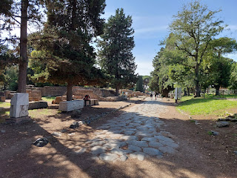

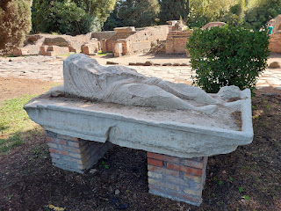

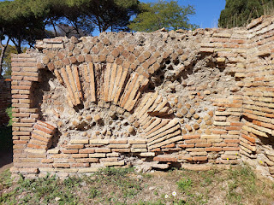

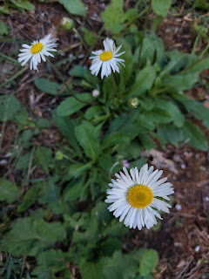

Unearthed and well-preserved flooring from one of the ancient buildings . . .

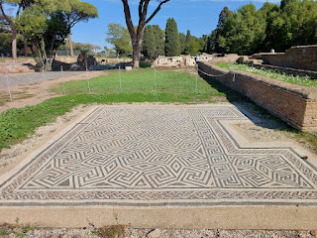

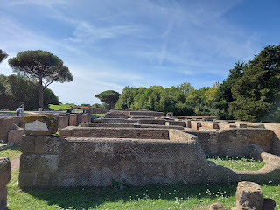

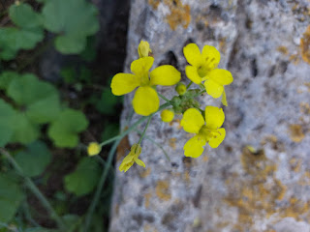

I will only be including a small portion of the explanatory signs and all the photos I took. I will include a link to everything below. (click this next photo to read about the streets)

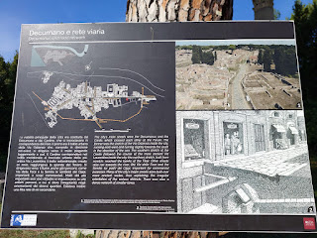

Me . . . taking a little rest . . .

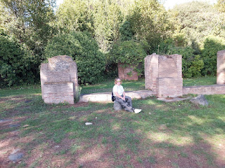

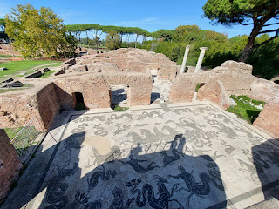

Video looking over the bath "rooms": (11 seconds)

https://photos.app.goo.gl/RJrgQN1FfGWbveR99

Video looking over the rest of the bath "rooms" and toward the main street: (15 seconds)

https://photos.app.goo.gl/17tRo7p58ScaAUvZA

A sign explaining the floor designs . . . (click photo to enlarge)

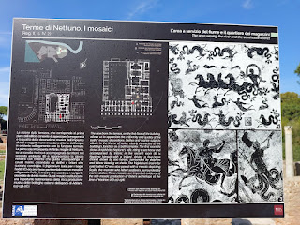

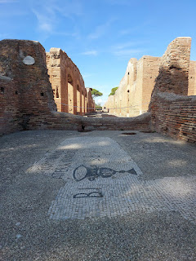

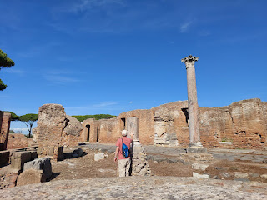

Super steep steps leading up to the Roman theater  . . .

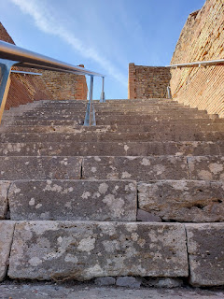

This theater used to hold 3,000 - 4,000 spectators back in the day . . .

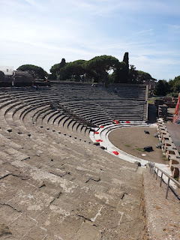

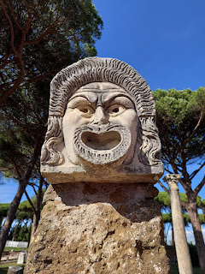

Below: I am standing on what used to be a temple and what is also theorized to have been the headquarters of trade for this region.

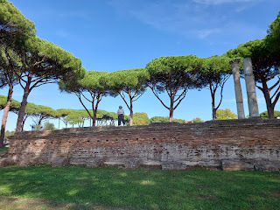

Scott and I had some theories of our own about these interesting "holes" . . . LOL

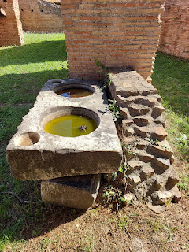

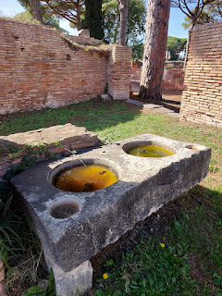

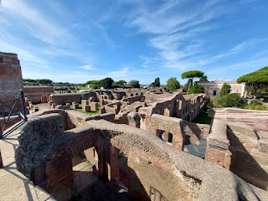

A sign describing the market district, with commercial shops and goods of all kinds . . .

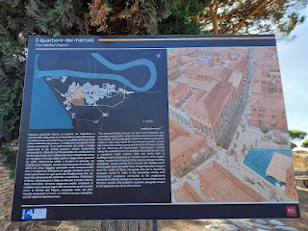

Take a little walk with me into a section just off the main street: (13 seconds)

https://photos.app.goo.gl/tdkL7PZ4TLMF9qK89

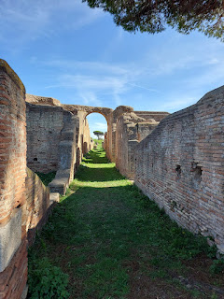

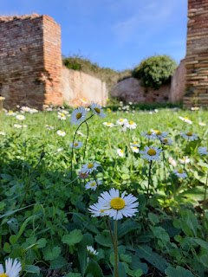

A video showing the immensity of Ostia Antica: (29 seconds)

https://photos.app.goo.gl/BJJ3S5pUZc6RM6uU8

You can see how it could take some serious time to explore the vast ruins, and to read all the signs, ha ha. If you're interested in seeing a little more, you are welcome to visit the album I made here:

https://photos.app.goo.gl/XdJNv2jk873YGwL57

After we walked all the way to the back end of the settlement, to what used to be the edge of the sea, we made our way all the way back to the front entrance once again. It was extremely

necessary

at this point that I find some gelato, and hallelujah, there was a gelateria right around the corner from where we parked. Yay!

We drove about 45 minutes to our AirBnB, known as B&B La Mia Casa per Tutti, located near Cerveteri. It was essentially a 4-plex house (with individual units) in the middle of farmland galore. It was very pretty - once we found the place, ha ha. The Google Maps pin on their website was not accurate, which led us to the wrong place at first. Scott pulled over so I could try to talk to this old Italian guy to get some help, using Google Translate as a buffer. After several minutes of struggling to communicate, I finally realized he was from SPAIN and therefore my using Italian on the translate app was of no use!! LOL

Meanwhile, Scott had better luck with another neighbor, who gave us very clear directions on how to get to the AirBnB. Once we did arrive, we made sure to add our own pin to the map on Scott's phone so we could navigate more easily the next time.

Pros

for this AirBnB: It was quiet and peaceful being surrounded by farmland. The apartment had a very comfortable bed and a lot of open space in each room. The kitchen was huge.  There was a pool - but it was a little too cold for swimming this late in the season.

Cons:

It was difficult to find and was a long way from restaurants and grocery stores (about 15 minutes by car).

I had a pretty decent sized headache, residual from being sick, but I had also gotten a little dehydrated as we tromped all over Ostia Antica for 2 hours. While I laid down to rest in the bedroom at the B&B, Scott had the best time helping the host family with harvesting some olives outside.

First, he watched them. And that's when he noticed Grandma (Nonna) struggling with the pruning. She was trying to reach some branches way above her head, which she did, but because they were so high, she couldn't get enough oomph to cut the branches with the pruners. She would try and try, but it wasn't working. So Scott jumped in to offer some assistance, which she gratefully accepted. They did not speak the same language at all, but she would point at which branch she needed trimmed, and Scott would trim it off. They worked like this for well over an hour. XOXO

He came in so happy when he was done. And he was only done because the sun was going down and the family decided to wrap up for the day. What a great guy.

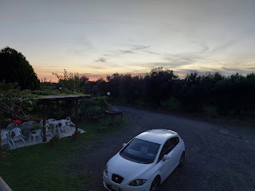

I had a good rest, though, while he was out there slaving away with our host family. I felt bad that I didn't contribute anything, but I needed some recovery time myself. Apparently, the family only had about 4 days to harvest all the olives from the trees and then get them all pruned. The reason for the rush was because they had an assigned day to process the olives at a local manufacturing plant where they can make their own olive oil. Everything needed to be done in time to make that appointment, and they only had maybe 4 people to work in the large orchard, including poor little Nonna.

A beautiful sunset and a peaceful pool at the end of the day . . .

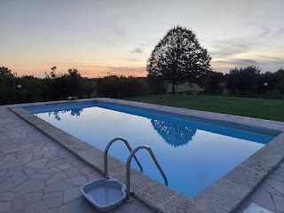

We freshened ourselves up and headed into town for dinner. I had done some research while I was resting, and we decided to head to a well-rated restaurant named El Chucharrito in Cerveteri. The drive to get into town was a little hair-raising, ha ha. Google told us to go down a country lane that looked like it was built for one direction only, but in fact, it was a two-way lane. On either side of the road was a deep ditch, with only occasional turnouts if someone was coming from the opposite direction. We had to use every single one . . . and it was pretty nuts if you ask me.

About 15 minutes later, we arrived at the restaurant . . . but something was off. It was closed, with a sign on the gated front window indicating that it was closed permanently. Thanks, Google. Now what?

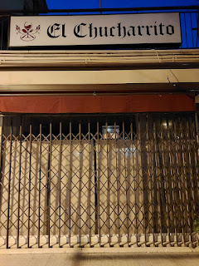

I took a photo of the storefront that was clearly out of business and uploaded it to Google, requesting them to change the status of the restaurant from "Open" to "Temporarily Closed". Within minutes, my submission was granted and the status had already changed online.

We walked around for a few minutes but didn't find anything else nearby. Soon, though, Scott found a very highly rated fish & chips place that we could drive to instead. It's called "Fish & . . . "

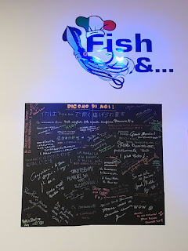

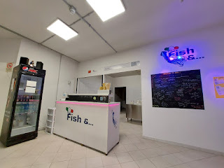

It was a very simple place, and extremely clean. They only serve a few things on the menu: calamari, cod, prawns, anchovies, paranza, latterini, mussels, and "chips" (or fries). They batter them up and fry them - all from scratch while you wait.

Short video as the chef is dredging our order with flour: (4 seconds)

https://photos.app.goo.gl/wSBPj4DmAuxURVZq8

About 10-15 minutes later, our food was ready to take home. It was seriously so delicious! Absolutely worth the 4.8 stars that this place is rated online. We brought home prawns, cod, and 2 orders of mussels, plus the fries. Everything was perfectly prepared - and even though we had no dipping sauces at all, we didn't even need them. I wish I could eat their fried mussels at least 7 days a week. :)

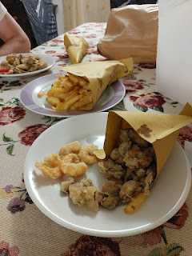

Day Four (of five):

After a good night's sleep, we got up early to prepare to go to church. Breakfast was served on the balcony above our unit. The hosts have a daughter (in her late 20's) that lives in one of the four units, who also speaks good English, so she was designated to serve us that morning.

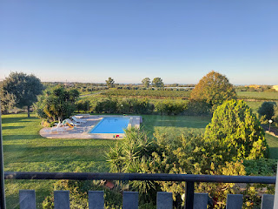

Breakfast was served in typical Italian fashion, with lots of carbs in the form of pastries, cereals, breads, juices, etc. Beautifully organized, but not really much that I could eat . . . I ended up choosing a yogurt and a croissant (in Italy they are called a brioche).

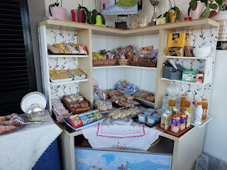

While the daughter prepared some hot water so I could have some tea, we had fun studying the maps where guests had pinned places where they hail from. Several people from Vicenza had made their mark here.

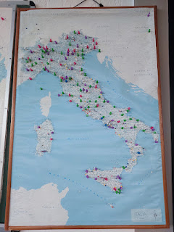

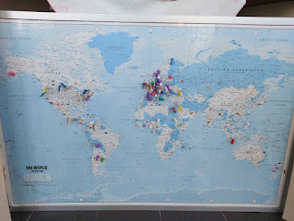

Nobody had placed a pin from Eastern Idaho, though, so Scott made sure we made our mark.

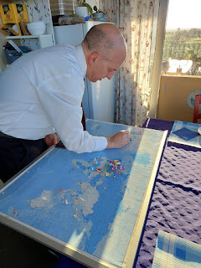

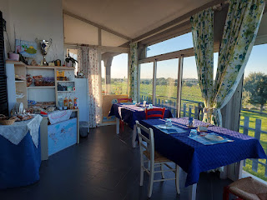

The morning views were beautiful as we ate our little breakfast on the balcony, watching the neighboring farmers heading out into the pumpkin fields to pick a few more whoppers, and Nonna and her kids began assembling down in the olive orchard again.

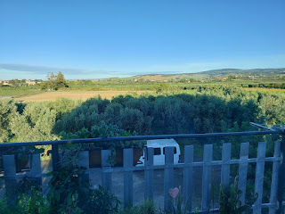

This would be a really fun place to visit during the warmer summer months, especially if you had kids with you. They have a trampoline in the yard, a swingset, and a good-sized swimming pool.

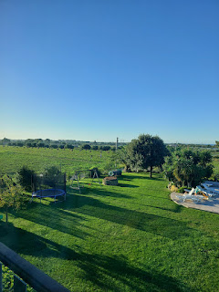

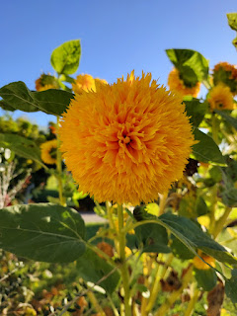

I loved that there were several flowers still blooming, even though the morning was crisp and chilly. Pomegranates were ripening, too, and this one was a WHOPPER!

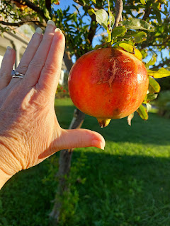

We said our goodbyes and loaded into the car. I took a little video of one of the guys using a vibrating rake tool to get the olives off the branches. It's a tedious and time-consuming task, "combing" one branch at a time, getting the olives to fall off onto the tarp below.

Video of the painstaking harvest process: (13 seconds)

https://photos.app.goo.gl/KmhCCcAmHjneY2T17

We drove past the pumpkin fields and I had Scott stop so I could get a picture. Unfortunately, the ground was wet with dew and was also a bit muddy, so I couldn't get very close in my heels. Just know that the many, many crates full to the brim with HUGE pumpkins were very impressive.

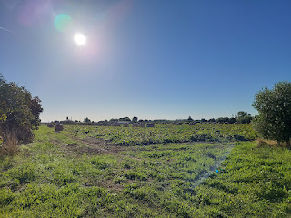

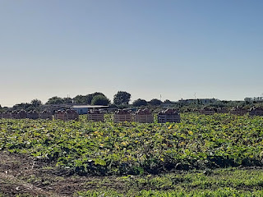

Church in Ladispoli was wonderful. The ward there was robust and filled to (almost) overflowing in their small chapel. It was a fast and testimony meeting, where the members have an opportunity to give up food and drink for a day and to have a spiritually-minded focus. During the Sacrament meeting, members also have an opportunity to share their testimony of the Gospel, especially examples of how their relationship with Jesus Christ has been strengthened recently.

The Rome Mission President and his wife were seated up on the stand, and they each shared a beautiful testimony of miracles they have seen while serving as missionaries in Italy. We noted that there almost seemed to be more children in the congregation than adults, which was very different from the last little Branch that we attended, where they only had 2 primary children. There were a variety of ethnicities and languages during this meeting, too. For example, a lady who was originally from England, did her best to speak in Italian, but she had the cutest British accent. Two other ladies had Spanish backgrounds and didn't speak Italian, so one of the counselors in the bishopric jumped up to translate. The lady would say a line or two in Spanish, then the counselor would translate it to Italian, which the sister missionary, in turn, translated into English for those of us with headsets. Amazingly, we got quite a bit out of the meeting, even with such a language barrier.

We also noted that we weren't the only ones needing a headset while the sister missionaries translated quietly into our ears. There was a family in front of us with headsets on, as well. I recognized the mother because I had seen her in the temple the day before. After the meeting concluded, I walked over so I could ask where they were visiting from. The mom shared a very interesting story with me. They are from the Atlanta, GA area and in recent months, they felt a very strong prompting to move to Italy. More specifically, to Ladispoli, of all places.

They had sold off everything that they could back in Georgia, packed their bags, and had just arrived a few days prior to this meeting. They had no idea why they were inspired to move here, but they came anyway. They were staying in an AirB&B until more permanent arrangements could be made. I inquired as to how they will support themselves . . . She is a Life Coach (I'm not sure exactly what this means) and plans to continue her practice in Italy over Zoom. Her husband plans to be her marketing director. Wow. What a huge leap of faith this family has taken! I wonder what God has in store for them in the near future . . .

As someone was guiding me to where the tiny little ladies bathroom was after Sacrament meeting was over (so I could change my clothes as we prepared to leave), the Mission President was in the hallway. I thanked him for sharing his heartfelt thoughts during the testimony meeting. We stood there visiting for several minutes. He wanted to know where we were from and what our background was. He had come to interview the missionaries as part of the rounds he makes as a mission president, so as soon as we were done visiting, off they all went. (His name was President Timothy Morris.)

Scott and I drove about 35 minutes up the coast to Civitavecchia. (Pronounced like "Chee-vee-ta-Vek-ee-ya") This was a really cute town, with a very long promenade along the water. We got lucky finding a parking spot relatively close to the harbor, and used our EasyPark App to pay for the spot.

The first thing we saw when we got down the street to the water's edge was this interesting memorial. Look closely at the spikes coming up from the main base . . . you will see the silhouettes of two men if you stand in just the right spot.

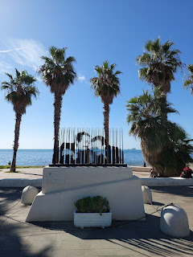

But it was the caption below their silhouettes that took my breath away. (Click photo below to read)

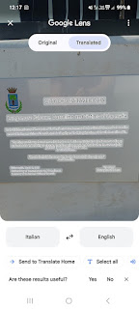

What a way to stand up to the mafia!! Oh my gosh. Very powerful words.

One of the reasons I wanted to come to Civitavecchia was because they have this statue next to the harbor . . . named, "Unconditional Surrender". It is one of many copies that have been placed in a variety of locations around the world. It was intended to represent an exciting time as servicemembers celebrated at the end of WWII.

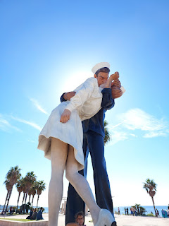

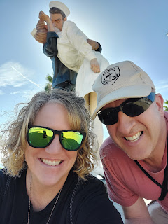

The only other place I've seen this same statue was in San Diego when I visited my sister in February of this year. In several locations, the name of the statue has been quietly changed to, "Embracing Peace", after there was some controversy as to whether the kiss and embrace were consensual or not. The artist who created these iconic pieces of art was J. Seward Johnson.

The same statue in San Diego, next to the USS Midway . . .

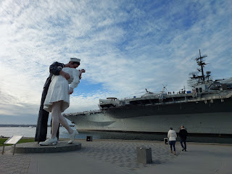

I understand the nature of the controversy, but because I am an optimist and choose to look on the bright side of things, I see it as an innocent portrayal of the peak emotions that everyone must have felt when the War's end was announced. Innocent excitement and impulsive celebrations.

Video of an odd creature we saw floating in the harbor of Civitavecchia: (16 seconds)

https://photos.app.goo.gl/qji44yq8dzpK9SCc6

After doing a little bit of research, I found out that this weird jellyfish species is known as the Compass Jellyfish. Take a look at the

third photo

in this short article about jellyfish in the Mediterranean Sea:

https://interparus.com/en/jellyfish-of-the-mediterranean-sea-whats-worth-knowing-before-encountering-them/

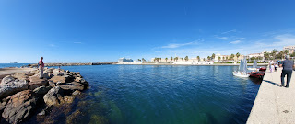

Scott looking all cute  . . .

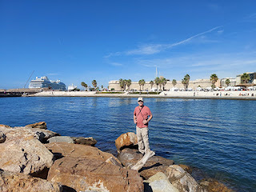

Video of the harbor: (25 seconds)

https://photos.app.goo.gl/s3Pnu6ZDhX6SjV3K8

Cruise ships dock in Civitavecchia, much like Ancona on the east side of Italy, but this town had a much smaller feel overall. We walked along the promenade for as far as we could before it was gated off (unless you were a ticketed passenger for one of the cruise ships). We also saw another cute "kissing statue", although this one was much smaller. Life-sized I would say.

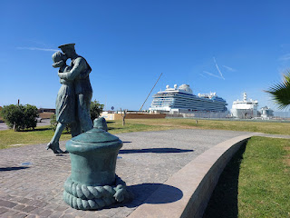

Next to the port and harbor area is an old fort known as Fort Michelangelo. Completed in 1535, it was built to protect the city and the region from pirates and other would-be attackers. And yes, Michelangelo was actually commissioned to design it. It is quite substantial in size and has a moat around it. While these photos don't do it justice, it would be really cool to see it lit up at night next to the water.

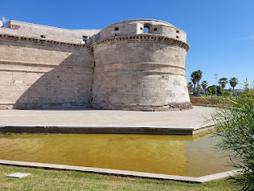

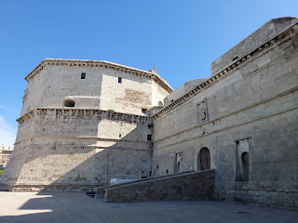

To give a little perspective, that's tiny little me in the photo below . . .

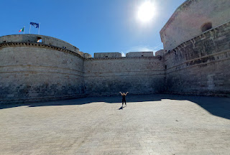

We found a lunch spot on the opposite side of Fort Michelangelo, called Cruise Cafe, with basic American offerings such as burgers and fries. We shared this burger meal because we're cute like that.

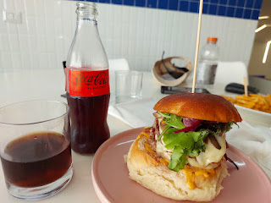

Next, it was time to get back on the road because we had a longer stretch of driving to get to Siena. During the 2.5 hours or so, we listened to several talks from the recent General Conference of The Church of Jesus Christ of Latter-day Saints. We are 99% caught up now. We enjoyed all of the messages of hope, faith, and inspiration as we drove along.

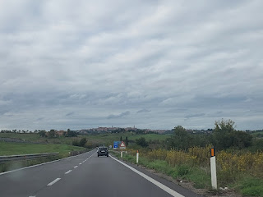

My messy notes about the highlights we wanted to see in Siena . . .

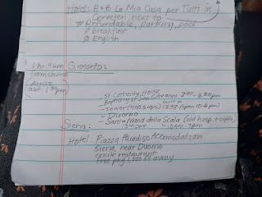

It was a Christmas-Day miracle that we found a parking place once we got to Siena . . . our hotel was in the historic district of downtown, where it's mostly a pedestrian-only zone, so we were told to park at a nearby parking lot. We found a smallish lot, and oh, my goodness. We had to do like a 12-point turn just to back into the tiny little spot at the end of the lane. We backed right up to a short rock-wall that offered some protection from the steep slope beneath and that overlooked the gorgeous Tuscan valley. I should have gotten a picture, but we were both a little traumatized from the effort just to park, ha ha.

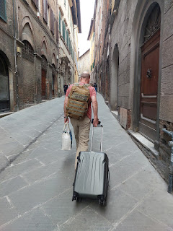

It was a 10-minute walk, mostly uphill, to get to our hotel. We stayed at the Piazza Paradiso Accomodation, which shares half of the building with Hotel Duomo. It was a really nice place, with a good sized bedroom and bathroom, and was a 5 minute walk from pretty much everything.

Pros:

the location, a comfortable bed, and a good price.

Cons:

No A/C after October 1st, so if you want fresh air you have to open the windows. This can let in the mosquitoes, but the bigger issue was the NOISE. It was unbelievably loud down below (we were on the 2nd floor - which in Europe is more like the 3rd floor). Not only could you hear every person and their loud conversations below as they walked by, but there were countless scooters and even occasional cars that would zoom by at all hours of the day and night. We alternated between having the windows open for a while, and then shutting them for a while so we could sleep.

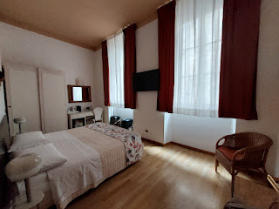

We took a walk shortly after getting settled at the hotel, heading over to the Siena Cathedral and Duomo first.

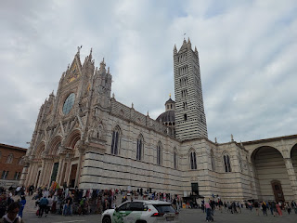

Video of a lady playing a stringed instrument, sort of like a harp: (33 seconds)

https://photos.app.goo.gl/x3WYtFSaEbYPLZzg8

If you're a fan of Rick Steves, you may recognize the episode where he stood on the steps in front of this very same spot.

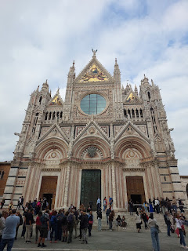

We decided to walk around the Duomo to the right and get some tickets to climb the Tower before the sunset. We bought a combo ticket which allowed us to see any of  5 tourist sights within 2 days, which was perfect for us. There was a bit of a wait to be able to climb up inside the Tower, as only very small groups could go at a time. The staff had a system of using walkie-talkies to communicate when the next group had arrived at the top, and when they were going to release them to come back down. This way, the narrow stairwells and spiral staircases would not be congested with two-way traffic.

While we waited, and slowly moved up the line, I spent some time admiring the large paintings on the wall next to us. The first artist was Girolamo Genga and his painting was created around the year 1511.

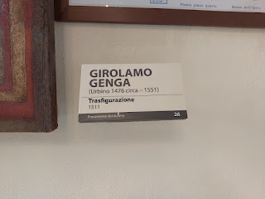

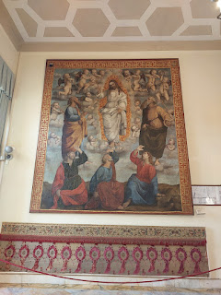

The next two paintings were made by Luigi Mussini around the year 1878.

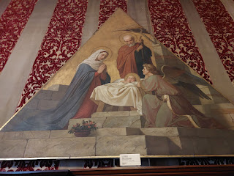

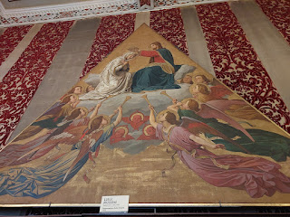

It was well worth the wait to get up to the views at the top . . . especially as the sun was beginning to set.

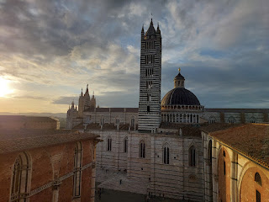

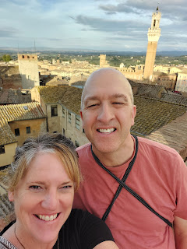

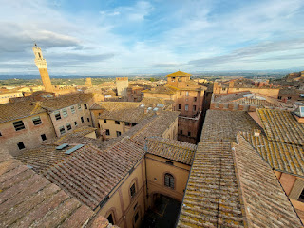

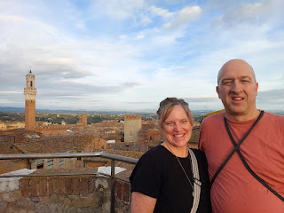

We climbed up to several different viewing platforms, each one higher than the previous one.

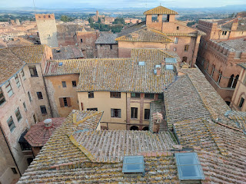

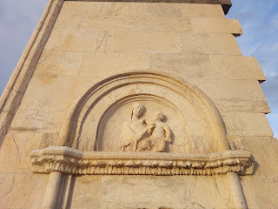

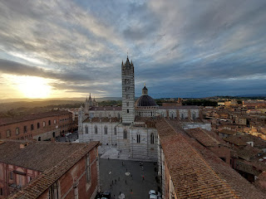

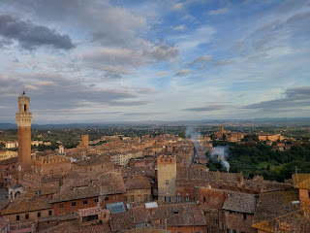

Below: The light danced off the tower of the Torre del Mangia off in the distance (Tower of the Eaters). The Tower is located in the huge piazza "Il Campo" and was named after its first bellringer, Giovanni di Balduccio, nicknamed "Mangiaguadagni", which means "profit eater". It could have had reference to him being a spendthrift, being idle, or being gluttonous. Wow, ha ha.

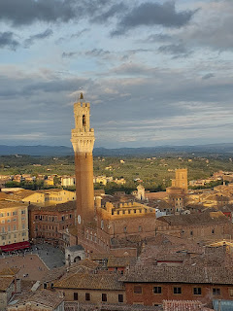

Video #1 of the views while the church bells ring: (22 seconds)

https://photos.app.goo.gl/cCANzQJWbd9DpPqc7

Video #2 of the bells ringing a very chaotic "song" at 6:00 pm: (15 seconds)

https://photos.app.goo.gl/Q5X6DDzrYYMC8AaS9

A portion of the stairs inside the Tower we climbed, which is adjacent to the Duomo and not to be confused with the Torre del Mangia.

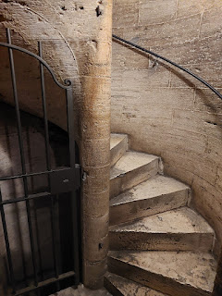

Back down inside the building, there are several rooms that you can explore with various art displays. I especially enjoyed this painting, where Jesus looks like a man-baby. The artist was Duccio Di Buoninsegna, and he created it in the year 1283 in Siena.

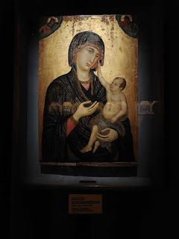

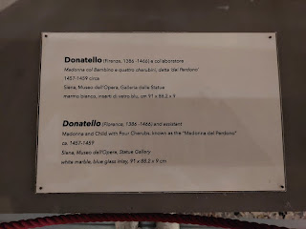

Above and below: The artist was Donatello, and the artwork was named, "Madonna del Perdono." I thought the stonework of Mary and Baby Jesus was especially beautiful.

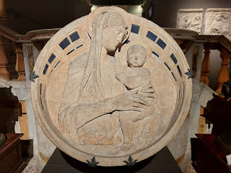

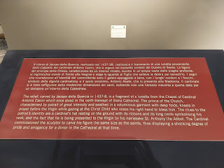

Above and Below: The sign is definitely worth reading in order to put the photo below into proper context.

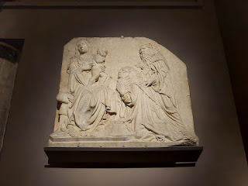

This stained glass window . . . it's so exquisite, I hardly have words for it . . .

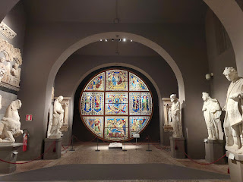

According to the description (below - and I'm sorry for the glare - I really tried to get rid of it), this beautiful and very large stained glass window was made around the year 1287. It was dismantled to protect it during WWII and then reinstalled later when it was safe to do so. The colorful scenes represent various stages of the Virgin Mary's life. I don't know where the idea of a Coronation came from, as described below, but I would imagine that when Mary died and went to heaven, there would have been quite a celebration for her there.

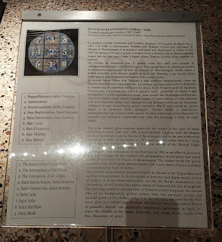

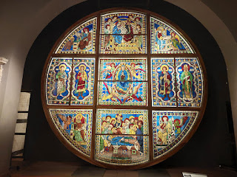

The last place we visited (as part of our combo tickets) was the Battistero di San Giovanni (Bapistery of St. John). It was built between 1316 and 1325, close to the base of the apse of the Duomo.

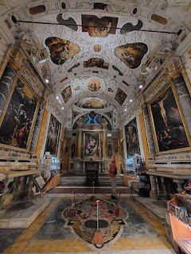

I didn't take as many photos here, mainly because we were on sensory overload by this point. My brain was pretty tired. So instead, I wandered briefly, just taking a few minutes to absorb the scene, and then I was ready to go.

For dinner, I got a personal pizza and Scott got a spicy kebab. :)

Video of the guy building my pizza: (18 seconds)

https://photos.app.goo.gl/gtqNsi7AJnYdqRdS7

Day Five:

Breakfasts in Italy are just not that great. Where's a good omelette place? Or even a cheap (but tasty) breakfast sandwich? The hotel gave us a voucher that was good for a meal down the street at a little cafe. We walked over and all they had were breads, thick breads, and even thicker breads with minimal lunchmeat in between the gigantic layers of bread. Scott had polished off my leftover pizza from the night before, so he wasn't hungry. It was just me, ha ha. I suggested we look for a little mini-market in the vicinity, and we found one right away across the cobblestone street.

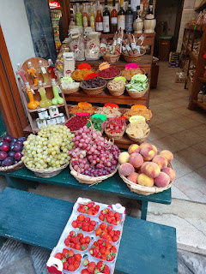

I enjoyed choosing several types of dried fruits (for our drive home later) and I also found a few little packaged food items that would make cute Christmas gifts. I bought a banana for my breakfast and all was well.

We dropped off some of our belongings to the car, pausing to admire this massive (yet unkempt) olive tree in the tiny parking lot. How sad that it has been neglected for so long.

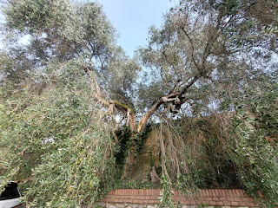

Miraculously, though, it still had some fruit on it that was almost ripe . . .

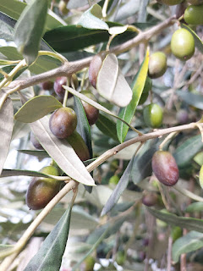

Back into town we went, making our way toward the Piazza del Campo, a famous landmark for Siena.

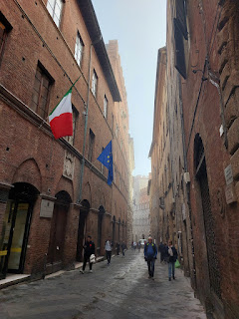

Steep sloped streets (try saying that 10x fast) lead to the grand plaza . . .

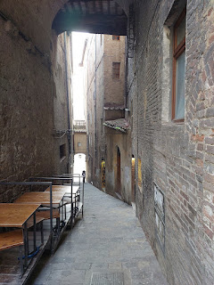

Video as we entered the plaza: (10 seconds) *I'm not sure why I gasped, but maybe I almost lost my footing or something.

https://photos.app.goo.gl/hoDBbMc61Ref5FR57

Video of the Piazza del Campo, with a mystical morning fog: (10 seconds)

https://photos.app.goo.gl/nrBLvAEzVzKtFaYR9

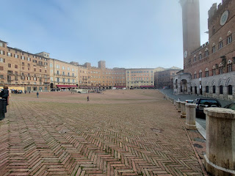

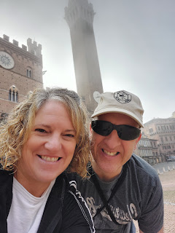

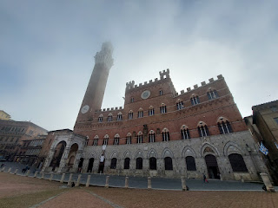

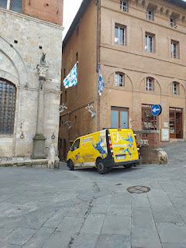

Here's a short video of how you sometimes have to wait a minute to walk in those narrow Italian "streets," because if you don't wait, you might get squished: (4 seconds)

https://photos.app.goo.gl/5RhzEPKdo4kR3Sjt5

The Piazza del Campo is famous for their twice yearly horse races around the long perimeter. It was used as a marketplace for some time before it was paved in 1349, the same stonework that we see today. During the race, known as Il Palio, 10 horses and riders are dressed in the colors of each neighborhood or "ward". The riders do not use a saddle, they ride

bareback

. This is a tradition that goes back to the 17th century (1633). Thick dirt is laid down to offer a little traction for the horses to get around those tight corners during the race. Also, it's not uncommon for horses to finish the race without their rider, as the rider may go flying off at some point!

There are 17 "wards" in Siena, but only 10 are represented each summer in Il Palio: the 7 that did not compete the year before, and 3 randomly drawn slots from the remaining wards. On Wikipedia, there is a list of each of the 17 wards along with their colors and mascot. For example, some of the mascots are: snail, eagle, caterpillar, dragon, unicorn, porcupine, goose, tortoise, etc.

You can read more about it here:

https://en.wikipedia.org/wiki/Palio_di_Siena

The races are usually held on 2 July and 16 August every year. My first thought was, "Whoof. What a hot time of year to assemble in the middle of a blazing Piazza!" The participants race around the perimeter of the Piazza for three total laps. The crazy part, is that you can choose to stand in the CENTER of the Piazza to watch the frenzied race, with nothing more than a thin gate between you and the whirlwind of horses and riders flying past . . . Hmmm. I'm not sure I would want to do that.

Here is what happened in July 2024: (on YouTube)

https://www.youtube.com/watch?v=OrShbV_P33A

Next, we went inside the Siena Cathedral itself, also known as the Duomo. The building of the Cathedral was completed in 1263, although it was built on the site of a much earlier church. Inside the Cathedral, they have a very helpful "map" of sorts, so you can get your bearings. Note that the overall shape was meant to resemble a cross.

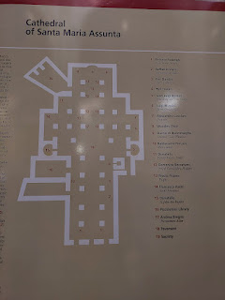

In 1339, an addition was planned to extend the structure, but there was a horrible plague in 1348 which decimated the population. This, in addition to some existing structural issues, caused their plans to be abandoned.

Inside the Duomo, the sheer height and magnitude is enough to make your ticket worthwhile. Take note of the dark blue ceiling, with gold stars. Just remember the height of this . . . I'll explain in a minute.

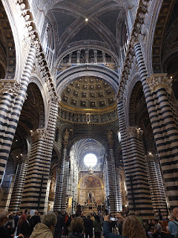

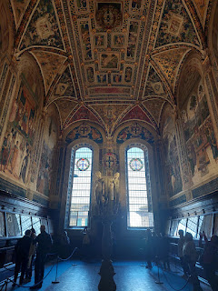

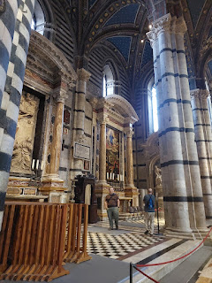

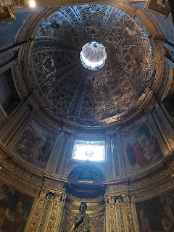

How these intricate circular domes were formed structurally and then decorated with the tiniest of details, just blows my mind.

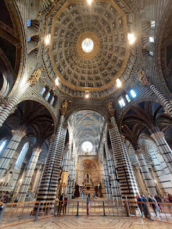

Scott studied this painting for the longest time . . .

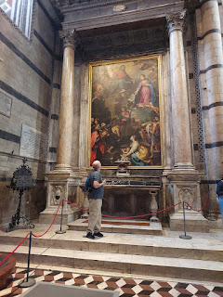

When I asked what he was thinking about, he told me to look at the figure in the center of the painting. It clearly looks like a woman and she appears to be annointing someone for religious purposes. Shocking, or at least surprising, isn't it? Women have not typically receive this form of power through the centuries of time.

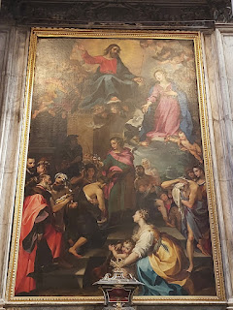

However, upon further research, we learned that even though it clearly looks like a woman, and even though "she" is wearing pink while other males are portrayed with reds, blues, and greens, it is not actually a woman.

The central figure is Saint Ansano, the patron saint of Siena, and HE is shown baptizing the Sienese people. He was often depicted wearing pink because:

1) Pink symbolizes joy, grace, and a holy gentle nature.

2) The use of pink may have also conveyed his innocence as a young martyr.

3) In Tuscan art, colors were sometimes used symbolically to represent virtues or attributes of saints, and pink would have evoked a sense of youthful dedication and purity.

4) His pink attire would help to distinguish him visually from other saints and would serve as a recognizable feature in other religious artwork from Siena.

What a fascinating little FYI and an interesting rabbit hole to go down.

At one point, during our visit to the Duomo, Scott noticed that the water bottle inside my cinch sack was leaking profoundly . . . it had come unlatched at the top and had soaked through the bag and was starting to get my backside all wet, too. In a matter of seconds, a puddle had formed on the marble floor of the Cathedral before we could dive into the bag and take care of the problem. I felt terrible, like I had desecrated a sacred place somehow. Eventually someone came to mop up the floor, but in the meantime, I tried to suppress a giggle as the people walking by noticed the puddle and subsequently sidestepped it, but they

all

looked up at the ceiling to see if there was a leak . . . lol.

As soon as we got home from Siena, I ordered a different water bottle from Amazon - one that actually LOCKS so that it won't leak. I just got it in the mail a week ago and it works fabulously.

After we finished our self-guided tour of the Duomo, we walked back over to the Piazza del Campo to get an early lunch. We were both hungry and figured it would serve us well to get a table at a restaurant before all the crowds and tour groups came looking for a spot soon, too. We chose to eat at Il Bandierino, on the far end of the plaza.

Scott had lost his hat and sunglasses in the Duomo (we tried 3x to check back in the hope of finding them that day, but to no avail). He probably tucked them on the floor next to his chair when we sat down to research that one painting. When we arrived at the restaurant, we wanted to eat outside because we thought it would be fun to do some people watching in the piazza during our meal, but it was SO BRIGHT. The waiter quickly offered to adjust the shades over the patio for us (they were mechanized). His kind and thoughtful gesture made for a perfect place for us to enjoy a lovely and leisurely lunch.

We ordered a Caesar Salad - which was good, but I think they used a Miracle Whip sort of base for the dressing, and I am NOT a fan.

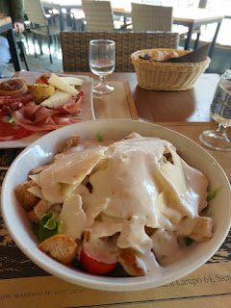

We also ordered a tasty charcuterie platter with meats, cheeses, breads, etc. It was really yummy.

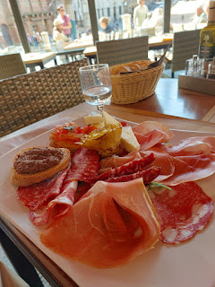

The one

scheduled

tour that we had set up the day before was called, "Porta del Cielo" (or Gate of Heaven), so that's where we headed after lunch. This tour allowed us to climb up and ABOVE where all the rest of the visitors walked around below on the main floor. This was Scott's absolute favorite part of Siena - the "behind the scenes" tour of the Duomo.

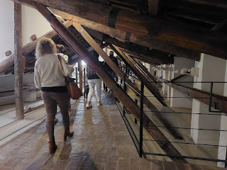

Click the photo below to see just how high up we were . . .

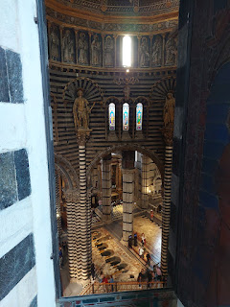

We were seeing the stained glass windows at eye-level . . .

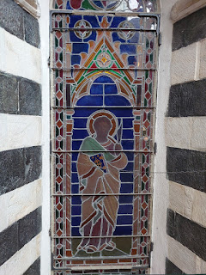

We carefully walked along a narrow path, stepping over the curved arches that were part of the cathedral below our feet . . . it was all pretty amazing. The next photo shows the literal rafters of the Cathedral . . .

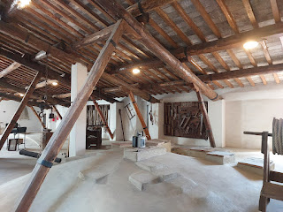

Scott was obsessed with this tactile board that included several samples of the various marble that had been used within the Cathedral. I took a photo and made a mental note to myself that maybe I should enlist the help of someone to turn this into a Christmas or birthday gift for him some day . . . He really loved the cold and smooth feel of the stone squares with all of the different designs.

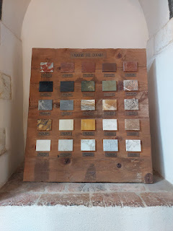

A crafted and ornate opening with views down into the Cathedral below . . .

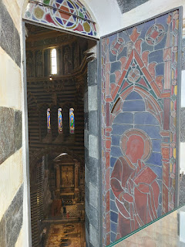

I can't even imagine how hard it would have been to build this edifice hundreds of years ago. The pulley system, the poor donkeys that were likely put to work, the wooden ladders and precarious scaffolding, etc. Those were some talented and incredibly smart engineers back then.

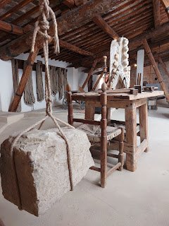

Our guided tour took us out onto a balcony, with sweeping views of Siena . . .

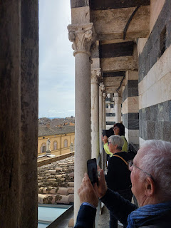

That arched tower straight across from us is where we had climbed up to the evening before, just as the sun was setting. I had wondered then who the people were across from us, and how did they get up there . . . Well, now I knew. :)

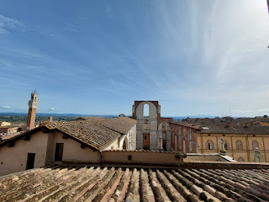

Something our guide mentioned to us is that some of the materials were hard to come by, or funding had possibly run out. That's why you can see the white and greenish black striped pattern from the ground below, but up on the balcony tour, we got to see the back side where there was only a simple brick facade in some areas.

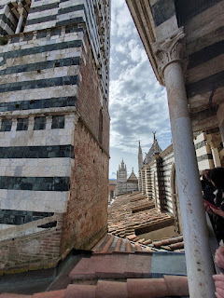

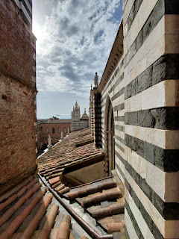

Remember that dark blue ceiling I mentioned earlier? Well, it was almost within reach of where we now stood . . .

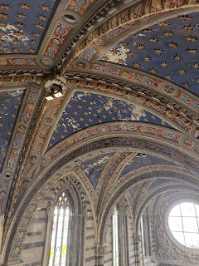

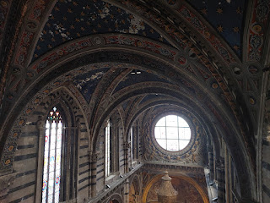

Video looking way down below: (9 seconds)

https://photos.app.goo.gl/C9hC6Uy8YLFzAEUX8

Up in the rafters is where it's at. You can see the incredible shapes and slopes of the architecture and design work from ABOVE . . .

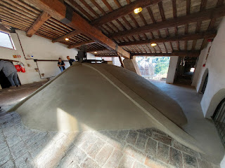

Short video as I followed Scott on the tour: (8 seconds)

https://photos.app.goo.gl/8b9iHEuWCCkB1zWd6

We stepped out onto another balcony, and moved along a sort of cat-walk around the south perimeter. I was especially captivated by the marble angels watching over everyone . . .

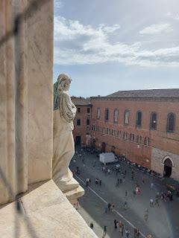

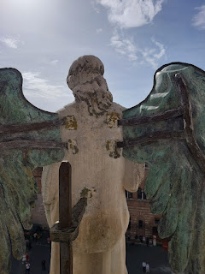

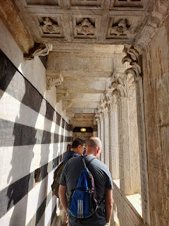

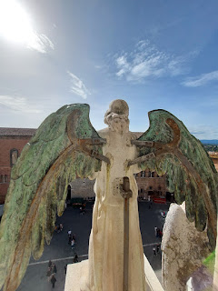

The Porta del Cielo tour was definitely worth the ticket and the wait for our appointed time slot. It was the #1 highlight of our time in Siena and something we will never forget!

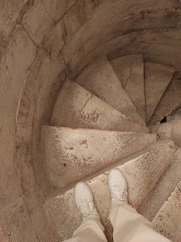

It was finally time to leave Siena and start making our way back to Vicenza. We passed through this arched gate one last time to get to our car.

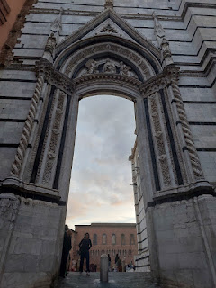

Scott sent the drone up from the tiny little parking lot, because the lush scenes below us in the beautiful Tuscan valley were oh so pretty.

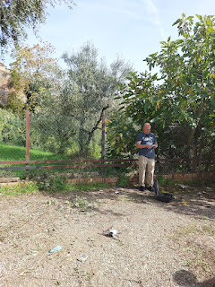

Unfortunately, when we got home, though, he noticed that there was something wrong with the footage. There was an error message and we couldn't even access the video. I am so sorry.

We made it home safely and now we have some perspective about the east coast and the west coast of Italy. At least for the middle section of the country . . .

Summary:

I loved Ravenna and Pesaro. (East Coast)

I really liked Ostia and Civitavecchia. (West Coast)

I definitely enjoyed Siena a lot, too. (Tuscany)

I don't need to visit Ancona or Ladispoli again.

Coming up:

We spent Veterans Day Weekend in Senj, Croatia, I also took a day trip with the ladies to Ravenna to make our own framed mosaic tile art, and I'll have some updates on the grandchildren, too. XOXO